Name:  Class: | ____________________________________  SCORE:  /  ________________
 | Year 12 General  2021  Topic – Right Angle Triangles and Geometry
Total Time: | 50 minutes
Weighting: | %
Equipment: | To be provided by the student: Pen, pencil, ruler, scientific calculator, 1 single sided page of A4 notes

Question 1 4 marks (2, 2)
Use the provided trigonometric ratio to calculate the missing value in the right angle triangle below:
[2, 2 = 4 marks]
  - Calculate the side length of x.
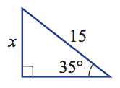
$sin θ= \frac{O}{H}$
15mm

  - Calculate the angle size of $θ.$ $tan θ= \frac{O}{A}$
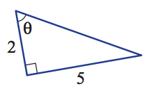

Question 2 6 marks (3, 3, 3)

Determine the value of the pronumeral in each of the following HINT Use Pythagoras Theorem

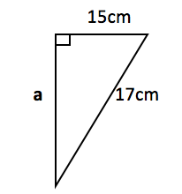
a) b)
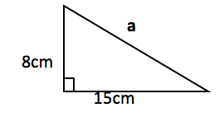

Question 3 6 Marks (3,3)

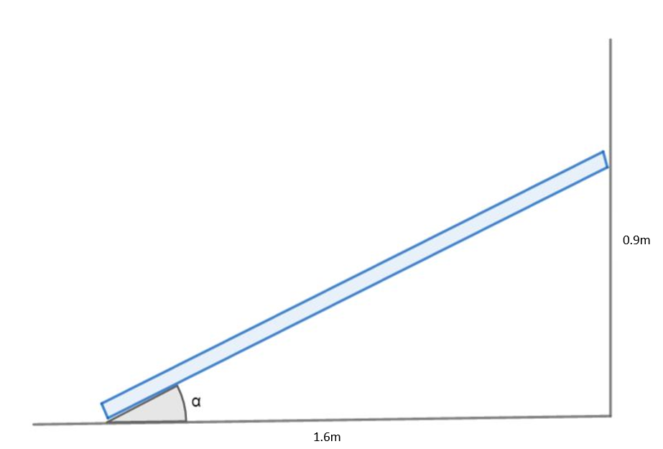

A ladder is used during the concrete manufacturing process. It is left leaning against the wall as shown above.
- Determine the length of the ladder.

- Determine the angle of inclination (or angle of elevation) α.

Question 4 8 Marks (2, 2, 2, 2)

The stair manufacturer also produces pre-cast concrete ramps to allow wheelchair access. A proposed design is shown below, using the dimensions of the stairs from question 1.
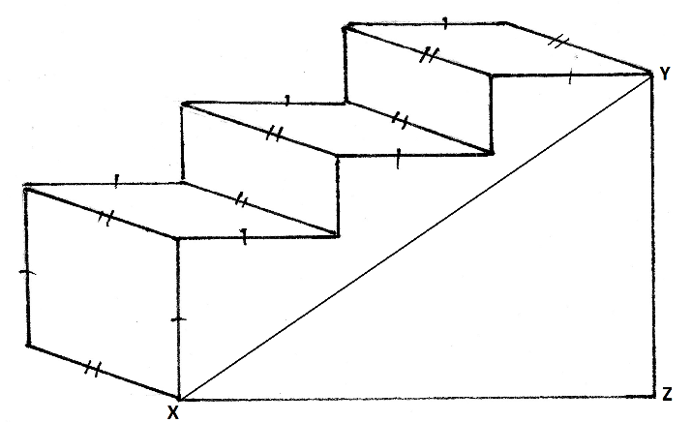

- Determine the length of the ramp from point X to point Y as shown on the diagram above using the dimensions from question 1.

- The ramp shown above is obviously too steep for wheelchair access. If the ramp length from point X to point Y is to be 20 metres long and the ramp must still reach the same height as the stairs, determine the horizontal length of the ramp from point X to point Z.

Question 7 7 Marks (3, 1, 1, 2)

: Find a° in the following diagrams. Give a mathematical reason as to how you got your answer. 4 marks

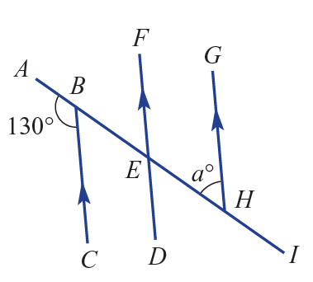  Answer: | 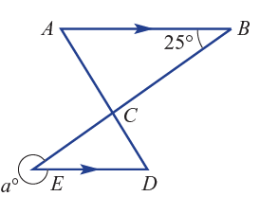  Answer:

Question 7 7 Marks (3, 1, 1, 2)

The angle of depression from the top of a tower that is 25 metres to a car on the ground is 62 degrees. Find the direct distance from the top of the tower to the car.

